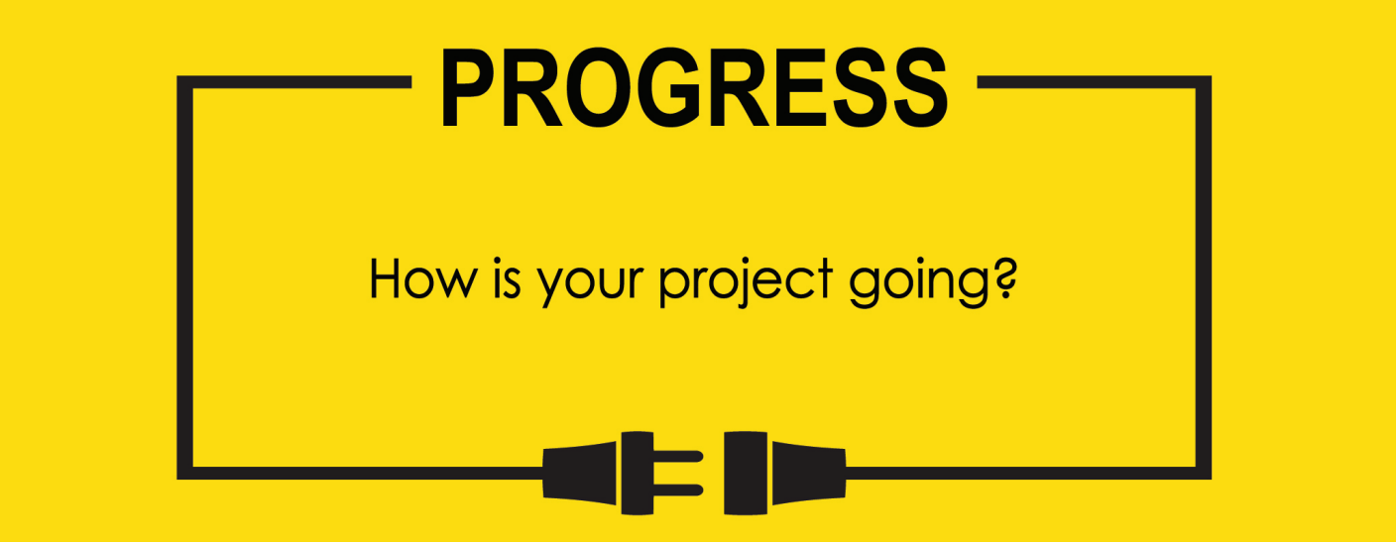

**Name: Zach Wilcox**

**Project Title: GreenBox**

**Previous Goals**

What were your three goals from last week? Were you able to complete them? If so, select Completed. If not, select the level of completion and explain in the Notes section why the goal was not completed, what still remains to be done, and when you expect to finish work on the goal.

Goal #1 from last week: Finish box build

**Status:** _____Completed ___x__Partially Completed _____No Progress

**Notes:**

Adhesive arrived, so sides and back have been ‘glued’ but still need to set up before continuing.

Goal #2 Finish sensor input code

**Status:** ___x__Completed _____Partially Completed _____No Progress

**Notes:**

Took more time than anticipated, but code has been completed. There weren’t any existing libraries for the sensor, so the manual and some online help had to be used to complete the sensor code, but as of now everything seems to be working as intended.

Goal #3 Finish GPIO output code

**Status:** _____Completed __x___Partially Completed _____No Progress

**Notes:**

Due to the sensor input code taking longer than anticipated, the output code (which depends on the sensor input) was not completed, though minor steps have been taken in using the initial input from the sensor function.

**Next Three Goals**

Choose three subtasks from your Gantt chart and use them to form goals that you plan to complete this week. In the text box beneath each goal, give details about what you plan to accomplish. Include details such as what materials are needed, how many hours each day you plan to devote to the task, and so on.

NOTE: THESE ARE INDIVIDUAL GOALS THAT YOU PLAN TO ACCOMPLISH. THESE ARE NOT TEAM GOALS.

**Goal #1:** Finish box build

**Goal #2:** Finish GPIO output code

**Goal #3:** Test I/O for sensor to system control

Humidity and Temperature sensor code.

Old Gantt chart

Box assembly extended, hardware interfacing extended, final assembly pushed

